8 BIT ADVANCED RISC PROCESSOR
A Project Based Learning Report Submitted in partial fulfilment of the requirements for the award of the degree

of

Bachelor of Technology
in The Department of Electronics and Communication Engineering
23VLS3303A and VLSI PHYSICAL DESIGN AUTOMATION
23SDEC18A and VLSI SUBMICRON DESIGN AND VERIFICATION
23VLS3202R and TESTING AND VERIFICATION OF VLSI CIRCUITS

Submitted by
2310040049: Vijaya Navya Sri
2310040045-SRinandini
2310049143: Srija Hitheshna

Under the guidance of
Dr. Kasi Bandla, Dr. Kayam SaiKumar & Dr. N. Phalguni Singh


Department of Electronics and Communication Engineering
Koneru Lakshmaiah Education Foundation, Aziz Nagar
Aziz Nagar – 500075
JAN - 2025.

1.INTRODUCTION

1.1 Background

The evolution of processor architecture has been one of the most pivotal advancements in the history of computing. Processors form the intellectual backbone of every digital system, from simple embedded controllers to high-performance computing clusters. Two dominant philosophies have shaped modern processor design: the Complex Instruction Set Computer (CISC) and the Reduced Instruction Set Computer (RISC). While CISC architectures, exemplified by Intel x86, offer powerful and complex instructions that can perform multi-step operations in a single cycle, RISC architectures prioritize simplicity, regularity, and speed by using a smaller set of simple instructions, each executing in a single clock cycle.

The RISC philosophy, pioneered in the early 1980s at UC Berkeley and Stanford University, has since become the foundation for some of the world’s most widely deployed processor families, including ARM, MIPS, SPARC, and RISC-V. The fundamental insight behind RISC is that most programs use only a small subset of complex instructions available in CISC architectures; therefore, optimizing the hardware for fast execution of simple instructions yields a better overall performance. This principle also lends itself naturally to pipelining, a technique where multiple instructions are overlapped in execution, significantly increasing throughput.

An 8-bit RISC processor, while modest in its data width, provides an ideal learning and research platform. It captures all the essential elements of a full-fledged RISC design — register files, ALU, control unit, memory interfaces, and status flags — while remaining tractable for simulation, synthesis, and verification. Eight-bit processors also continue to find extensive practical use in microcontroller applications such as AVR (ATmega series) and PIC processors, which power billions of embedded devices worldwide.

1.2 Motivation

The primary motivation behind designing a custom 8-bit RISC processor is to gain a deep, hands-on understanding of computer organization and architecture from first principles. Commercial processors are extraordinarily complex, making it difficult to trace the path from an instruction to its physical execution. A custom processor design, by contrast, exposes every wire, register, and control signal. This project serves as an educational vehicle that bridges theoretical knowledge (digital logic, computer architecture, HDL programming) with practical implementation on real hardware.

Furthermore, custom RISC processors are increasingly relevant in the era of domain-specific accelerators. As general-purpose processors approach the limits of Moore’s Law and Dennard scaling, architects are turning to specialized processors tuned for specific workloads. Understanding how to design a processor from scratch is therefore not just academically valuable but also industrially relevant.

1.3 Objectives
- To design a complete 8-bit RISC processor architecture incorporating all fundamental subsystems.
- To implement a 16-bit Program Counter and Address Bus enabling access to a 64 KB memory space.
- To design a Register File with eight general-purpose 8-bit registers supporting fast operand access.
- To develop an ALU capable of performing arithmetic, logical, shift/rotate, and compare operations.
- To implement a Control Unit with an Instruction Decoder and Finite State Machine for instruction execution.
- To simulate and verify the design using industry-standard HDL simulation tools.
- To explore synthesis and deployment on an FPGA platform.

1.4 Scope of the Project

The scope of this project covers the architectural design, HDL implementation, functional simulation, and synthesis of an 8-bit RISC processor. It encompasses all major components as shown in the block diagram: Clock and Reset logic, Control Unit, Program Counter, Instruction and Data Memory interfaces, Instruction Register, Data Bus, Register File, ALU, Status Register, Stack Pointer, and External I/O Interface. The design follows Harvard architecture principles with separate instruction and data memory paths.

2.LITERATURE SURVEY

2.1. Historical Context and Foundational Work
The RISC architecture philosophy emerged in the early 1980s through pioneering research at UC Berkeley and Stanford University. David Patterson's Berkeley RISC project and John Hennessy's MIPS project at Stanford fundamentally challenged the prevailing CISC design paradigm by demonstrating that simpler instruction sets could achieve higher performance through efficient pipelining and faster clock rates. Their seminal work "Computer Architecture: A Quantitative Approach" established key RISC principles: a small, orthogonal instruction set, load-store architecture with operations only between registers, simple addressing modes, and fixed-length instruction formats. These foundational concepts directly influenced commercial processors like ARM, MIPS, and SPARC, proving that complexity should reside in software rather than hardware.

2.2. Contemporary 8-Bit RISC Implementations
Modern literature on 8-bit RISC processors focuses primarily on educational implementations and embedded system applications. Researchers have published numerous FPGA-based designs that demonstrate RISC principles at a manageable scale. Notable implementations include single-cycle and pipelined variants using Verilog and VHDL, often targeting Xilinx or Altera FPGA platforms. Studies by Kumar et al. and Patel et al. have explored various optimization techniques including instruction set minimization, register file organization, and control unit design strategies. The literature emphasizes trade-offs between hardware complexity, instruction density, and execution speed, with many implementations achieving clock frequencies between 50-100 MHz on modern FPGAs while maintaining low resource utilization.

2.3. Instruction Set Architecture Research
Research on 8-bit RISC instruction sets reveals convergence toward certain optimal configurations. Most successful designs implement 16 to 32 core instructions covering data movement, arithmetic/logical operations, branching, and stack manipulation. Studies have analyzed instruction encoding schemes, with most 8-bit processors using either 8-bit or 16-bit instruction words depending on addressing requirements. Work by Singh and Chowdhury demonstrates that carefully chosen instruction sets can achieve good code density despite RISC's typically lower instruction density compared to CISC. Research also addresses addressing mode selection, with most 8-bit RISC designs supporting 3-5 modes: immediate, register direct, register indirect, and indexed addressing, balancing flexibility against decoding complexity.

2.4. Hardware Implementation Methodologies
The literature presents diverse implementation approaches for 8-bit RISC processors. Hardware description language (HDL) based designs dominate academic research, with comparative studies evaluating Verilog versus VHDL for processor design in terms of simulation speed, synthesis results, and design productivity. FPGA implementation studies focus on resource optimization, timing analysis, and power consumption, with research showing that 8-bit RISC processors typically consume 500-2000 logic elements on modern FPGAs. Some researchers have explored asynchronous design techniques for low-power applications, while others investigate multi-cycle and pipelined implementations to improve throughput. Recent work has also examined soft-core processors as alternatives to commercial IP cores, emphasizing customizability and educational value.

2.5. Design Verification and Testing
Literature on processor verification emphasizes systematic testing methodologies essential for ensuring correct operation. Researchers employ simulation-based verification using comprehensive test benches that validate each instruction individually and in combination. Formal verification techniques using model checking and theorem proving have been applied to small processor designs to mathematically prove correctness properties. Studies discuss test program development strategies, including directed tests for specific instructions and random instruction sequence generation for coverage analysis. Performance evaluation metrics discussed in literature include instructions per cycle (IPC), clock frequency, code size efficiency, and hardware resource utilization, providing standardized benchmarks for comparing different implementations.

2.6. Applications and Future Directions
Current research explores applications of 8-bit RISC processors in embedded systems, IoT devices, and educational platforms. Studies demonstrate their suitability for control applications, sensor interfacing, and simple data processing tasks where low power consumption and cost are priorities. Educational literature emphasizes these processors as teaching tools for computer architecture courses, providing students hands-on experience with complete system design. Emerging research directions include integration with peripheral controllers, exploration of custom instruction set extensions for specific applications, and investigation of security features like instruction encryption and secure boot mechanisms. The literature suggests continued relevance of 8-bit RISC processors in resource-constrained environments and educational contexts despite the dominance of 32-bit and 64-bit processors in mainstream computing.

3.METHODOLOGY
3.1 Architectural Philosophy
The designed processor adheres to the Harvard Architecture model, which physically separates instruction memory from data memory. This separation allows the processor to simultaneously fetch the next instruction from Instruction Memory (ROM) while accessing data in Data Memory (RAM) during the execution of the current instruction. In contrast, the Von Neumann architecture uses a single shared memory bus, creating a bottleneck known as the "Von Neumann bottleneck." The Harvard model thus provides a natural performance advantage and is widely used in embedded microcontrollers.
The processor follows a load-store architecture, meaning that arithmetic and logic operations are performed exclusively on register operands, and dedicated LOAD and STORE instructions transfer data between registers and memory. This reduces instruction complexity and allows the ALU to be highly optimized for register-to-register operations.

3.2 Bus Architecture
The processor employs a dual-bus architecture reflecting the asymmetry between address space and data width:

Bus | Width | Purpose | Connected to
Address Bus | 16-Bit | Carries memory Addresses | PC, Instruction Memory, Data Memory
Data Bus | 8-bit | Transfers data/instructions | Register File, Data Memory, IR
Control Bus | Multiple signals | Carries control signals | All components via Control Unit

The 16-bit address bus enables the processor to directly address 2^16 = 65,536 memory locations (64 KB), which is the full capacity of the Data Memory RAM. The 8-bit data bus transfers one byte at a time, consistent with the processor’s 8-bit data word size.

3.3Top Level Block Diagram Description
The architecture organizes components into a hierarchical data flow:
- Clock & Reset feeds synchronization signals to the Control Unit, ensuring all state transitions occur on defined clock edges.
- The Control Unit decodes instructions and generates control signals (shown as dashed red lines) that govern the behavior of all other blocks.
- The Program Counter (PC) drives the 16-bit Address Bus to fetch instructions from Instruction Memory.
- Fetched instructions travel from Instruction Memory via the Address/Data path into the Instruction Register (IR).
- Decoded instructions direct the Register File to output operands A and B to the ALU.
- The ALU computes results and writes them back to the Register File via the 8-bit Data Bus, while flag outputs update the Status Register.
- Data Memory (RAM) is accessed via both the 16-bit Address Bus and 8-bit Data Bus for LOAD/STORE operations.
- The Stack Pointer (SP) maintains the top-of-stack address for subroutine and interrupt handling.
- The External I/O Interface provides the processor's connection to the outside world through input/output ports and an interrupt controller.

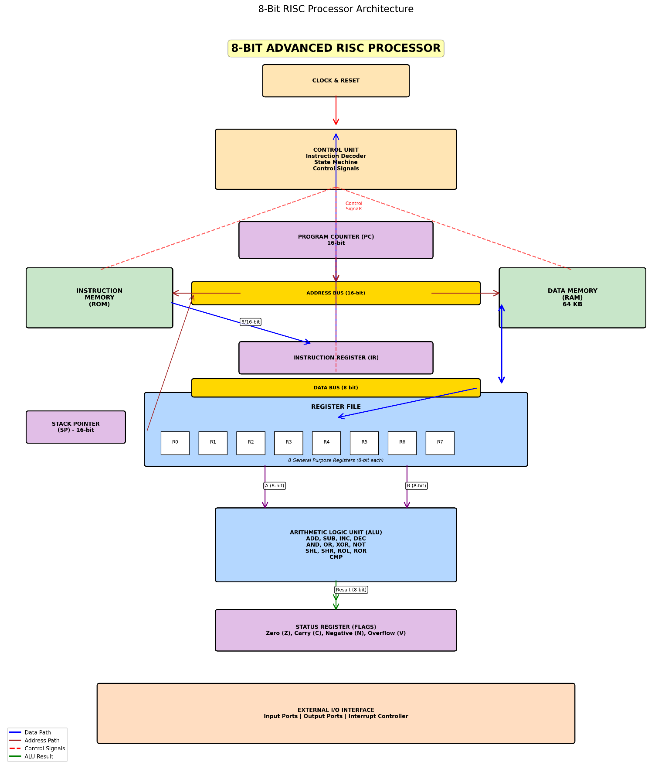

3.4 Signal Types

Four distinct signal types are used throughout the architecture, color-coded in the block diagram:

Signal Type | Color | Description
Data Path | Blue (solid) | Carries actual data values between components
Address Path | Purple (solid) | Carries memory addresses from PC to memory
Control Signals | Red (dashed) | Directs operation of each functional block
ALU Result | Green (solid) | Carries computed results from ALU to register file

4. DESCRIPTION

4.1 Clock and Reset Unit
The Clock and Reset block is the heartbeat of the entire processor. A global clock signal synchronizes all sequential logic elements (flip-flops, registers, state machines) ensuring consistent, glitch-free operation. The clock frequency determines the processor's performance; typical 8-bit RISC designs operate between 1 MHz and 20 MHz in FPGA implementations.
The synchronous reset signal initializes all registers and state machines to well-defined power-on states. On reset assertion, the Program Counter is cleared to address 0x0000, the Register File is zeroed, and the Control Unit FSM returns to its initial FETCH state. Designers may implement either synchronous reset (asserted on the clock edge) or asynchronous reset (asserted immediately), with synchronous being preferred for FPGA synthesis due to better timing closure.

4.2 Control Unit
The Control Unit is the most critical and complex block in the processor. It is responsible for orchestrating the operation of all other components in the correct sequence. The Control Unit contains three logical sub-units.

4.2.1 Instruction Decoder
The Instruction Decoder takes the opcode bits from the Instruction Register (IR) and decodes them into a set of control signals. For an 8-bit RISC processor, a typical instruction format might use the upper 4 bits as the opcode (allowing 16 instruction classes) and the lower 4 bits for register addressing or immediate values. The decoder is implemented as combinational logic (a large multiplexer or ROM-based lookup table).

4.2.2 Finite State Machine (FSM)
The FSM implements the instruction execution cycle. A basic RISC execution follows three to five states: FETCH (read instruction from memory), DECODE (determine operation), EXECUTE (perform operation), MEMORY ACCESS (read/write data memory if needed), and WRITEBACK (store result to register). The FSM advances through these states on each clock cycle, generating appropriate control signals at each stage. For a single-cycle implementation, all states collapse into one clock period.

4.2.3 Control Signal Generation
Control signals generated by the Control Unit include: PC_Enable (advance program counter), IR_Load (latch instruction into IR), RegFile_Write (enable register write), ALU_Op[3:0] (select ALU operation), Mem_Read, Mem_Write, Data_Mux_Select (choose between ALU result and memory data), and Stack_Op (push/pop stack). These signals flow to every component via the control bus (dashed red lines in the diagram).

4.3 Program Counter (PC)
The Program Counter is a 16-bit register that holds the address of the next instruction to be fetched. On each FETCH cycle, its value is driven onto the 16-bit Address Bus to select the appropriate instruction from Instruction Memory. After each instruction fetch, the PC is automatically incremented by 1 (or by 2 for two-word instructions). For branch and jump instructions, the Control Unit loads the target address directly into the PC rather than incrementing it. The 16-bit width provides a 64 KB addressable instruction space, which is more than adequate for most embedded applications.

4.4 Instruction Memory (ROM)
Instruction Memory is implemented as Read-Only Memory (ROM) in the classic Harvard model, reflecting the fact that programs are typically fixed and do not modify themselves at runtime. In an FPGA implementation, this ROM is realized using Block RAM (BRAM) initialized with the compiled program binary. The ROM is addressed by the 16-bit Address Bus and outputs an 8-bit instruction word (or 16-bit for extended instructions) onto the data path leading to the Instruction Register. Separate instruction memory also prevents self-modifying code vulnerabilities.

4.5 Instruction Register (IR)
The Instruction Register is an 8-bit (or 16-bit for wider instruction formats) register that holds the currently executing instruction. After the PC addresses Instruction Memory and the memory outputs the instruction word, the IR latches this word under control of the IR_Load signal. The IR's output is fed directly to the Instruction Decoder in the Control Unit, which then generates the appropriate control signals for the execution phase. The IR insulates the rest of the datapath from the instruction fetch timing.

4.6 Register File
The Register File is a small, fast array of eight 8-bit general-purpose registers labeled R0 through R7. It is the primary workspace for all computation — ALU operations read their operands from the Register File and write results back to it. The Register File supports:
- Dual-port read: Two registers (A and B operands) can be read simultaneously in one clock cycle.
- Single-port write: One register can be written per clock cycle (the result from ALU or data from memory).
- Addressing: Each register is addressed by a 3-bit field in the instruction word (2^3 = 8 registers).

Compared to a single accumulator design, an eight-register file dramatically reduces the number of memory accesses required, since intermediate values can be held in registers rather than being stored and reloaded from memory. This is a cornerstone of RISC efficiency.

4.7 Arithmetic Logic Unit (ALU)
The ALU is the computational engine of the processor. It receives two 8-bit operands (A from source register 1, B from source register 2 or an immediate value), performs the selected operation, and outputs an 8-bit result. The operation is selected by a 4-bit ALU_Op control code from the Control Unit. The full set of supported operations is:

Category | Operations | Description
Arithmetic | ADD, SUB | 8-bit addition and subtraction with carry/borrow
Increment/Decrement | INC, DEC | Increment or decrement register by 1
Logic | AND, OR, XOR, NOT | Bitwise logical operations on 8-bit operands
Shift | SHL, SHR | Logical shift left/right by one bit position
Rotate | ROL, ROR | Rotate through carry flag left/right
Compare | CMP | Subtract operands and update flags without saving result

The ALU also generates flag outputs that are captured by the Status Register after each operation. The design of the ALU as a purely combinational block (no internal state) keeps latency minimal and timing predictable.

4.8 Status Register (Flags)

The Status Register is a special 4-bit register that captures condition codes from ALU operations:

Flag | Symbol | Set When | Use Case
Zero | Z | ALU result is 0x00 | BEQ (Branch if Equal), loop termination
Carry | C | Addition overflows 8 bits or shift shifts out a 1 | Multi-byte arithmetic, BCS/BCC instructions
Negative | N | MSB (bit 7) of result is 1 | BLT (Branch if Less Than) for signed arithmetic
Overflow | V | Signed arithmetic overflow occurs | Detecting errors in signed arithmetic

Conditional branch instructions (BEQ, BNE, BCS, BCC, BMI, BPL, BVS, BVC) test these flags to determine whether to modify the Program Counter or continue sequential execution. This mechanism implements all high-level.

4.9 Data Memory (RAM)
Data Memory is a 64 KB Random Access Memory used to store variables, arrays, stack frames, and heap data during program execution. It is addressed via the 16-bit Address Bus and transfers data via the 8-bit Data Bus. The RAM supports both READ (LOAD instruction) and WRITE (STORE instruction) operations. In FPGA implementations, this is typically realized using on-chip Block RAM or distributed RAM. The Harvard architecture ensures that data memory access does not stall instruction fetch operations.

4.10 Stack Pointer (SP)
The Stack Pointer is a 16-bit register that tracks the top of the hardware stack in Data Memory. It is used to support subroutine calls (CALL/RET instructions) and interrupt service routines. When a CALL instruction is executed, the current PC value (return address) is pushed onto the stack and SP is decremented. When RET is executed, SP is incremented and the return address is popped back into the PC. The 16-bit width allows the stack to reside anywhere in the 64 KB data memory space, with depth limited only by available memory.

4.11 External I/O Interface
The External I/O Interface is the processor's gateway to the physical world. It provides:
- Input Ports: Allow the processor to read digital signals from external devices such as switches, sensors, keyboards, and serial receivers. Typically, memory-mapped to specific addresses in the address space.
- Output Ports: Allow the processor to drive external devices such as LEDs, displays, actuators, DACs, and serial transmitters.
- Interrupt Controller: Manages asynchronous events from external sources. When an interrupt is asserted, the controller saves the current CPU state, vectors to an Interrupt Service Routine (ISR) address, and restores state on return. This allows the processor to respond to real-time events without polling.

5. Instruction Set Architecture (ISA)

5.1 Instruction Format
Each instruction is 8 bits wide, divided into fields as follows:

Bits | Field | Size | Description
[7:4] | Opcode | 4 bits | Identifies the instruction type (16 possible opcodes)
[7:4] | Destination Reg (Rd) | 2 bits | Target register (R0–R3 in compact format)
[1:0] | Source Reg (Rs) | 2 bits | Source register or immediate select

For instructions requiring a full 3-bit register address (accessing R0–R7), a 16-bit extended instruction format is used, where the second byte carries the full register address and any immediate value. This hybrid approach balances code density with register file accessibility.

5.2 Instruction Categories

Category | Instructions | Example Syntax | Operation
Data Transfer | LOAD, STORE, MOV | LOAD R1, [R2] | R1 ← Memory[R2]
Arithmetic | ADD, SUB, INC, DEC | ADD R0, R1, R2 | R0 ← R1 + R2
Logic | AND, OR, XOR, NOT | AND R0, R1, R2 | R0 ← R1 AND R2
Shift/Rotate | SHL, SHR, ROL, ROR | SHL R0, R1 | R0 ← R1 << 1
Compare | CMP | CMP R0, R1 | Flags ← R0 − R1
Branch | BEQ, BNE, BCS, BCC | BEQ LABEL | If Z=1, PC ← LABEL
Jump | JMP, CALL, RET | CALL SUB1 | Push PC; PC ← SUB1
Stack | PUSH, POP | PUSH R0 | Mem[SP––] ← R0
I/O | IN, OUT | OUT PORT0, R1 | Port0 ← R1
Miscellaneous | NOP, HALT | NOP | No operation

5.3 Addressing Modes
- Register Direct: Operand is in a register. Example: ADD R0, R1, R2.
- Immediate: Operand is a constant embedded in the instruction. Example: LOAD R0, #0x3F.
- Register Indirect: Memory address is held in a register. Example: LOAD R1, [R2].
- Direct (Absolute): Memory address is specified directly in the instruction. Example: STORE [0x00FF], R3.

6.SOURCE CODE
6.1 HDL Description

// ============================================================
// 8-Bit Advanced RISC Processor – EDA Playground Compatible
// Tool: Icarus Verilog (iverilog)
// Run: Check "Open EPWave after run" for waveforms
// ============================================================
`timescale 1ns/1ps

// ============================================================
// ALU – 13 Operations
// ============================================================
module alu (
input [7:0] A,
input [7:0] B,
input [3:0] op,
output reg [7:0] result,
output reg Z, C, N, V
);
localparam ADD=4'd0, SUB=4'd1, INC=4'd2, DEC=4'd3,
AND=4'd4, OR =4'd5, XOR=4'd6, NOT=4'd7,
SHL=4'd8, SHR=4'd9, ROL=4'd10, ROR=4'd11,
CMP=4'd12;

reg [8:0] tmp;

always @(*) begin
tmp = 9'd0;
result = 8'd0;
C = 0; V = 0;

case (op)
ADD: begin
tmp = {1'b0,A} + {1'b0,B};
result = tmp[7:0];
C = tmp[8];
V = (A[7]==B[7]) && (result[7]!=A[7]);
end
SUB: begin
tmp = {1'b0,A} - {1'b0,B};
result = tmp[7:0];
C = tmp[8];
V = (A[7]!=B[7]) && (result[7]!=A[7]);
end
INC: begin
tmp = {1'b0,A} + 9'd1;
result = tmp[7:0];
C = tmp[8];
end
DEC: begin
tmp = {1'b0,A} - 9'd1;
result = tmp[7:0];
C = tmp[8];
end
AND: result = A & B;
OR : result = A | B;
XOR: result = A ^ B;
NOT: result = ~A;
SHL: begin {C, result} = {A, 1'b0}; end
SHR: begin {result, C} = {1'b0, A}; end
ROL: begin result = {A[6:0], A[7]}; C = A[7]; end
ROR: begin result = {A[0], A[7:1]}; C = A[0]; end
CMP: begin
tmp = {1'b0,A} - {1'b0,B};
result = tmp[7:0];
C = tmp[8];
V = (A[7]!=B[7]) && (result[7]!=A[7]);
end
default: result = 8'd0;
endcase

Z = (result == 8'd0);
N = result[7];
end
endmodule

// ============================================================
// Register File – 8 x 8-bit (R0 to R7)
// ============================================================
module register_file (
input clk,
input rst,
input [2:0] rs1,
input [2:0] rs2,
input [2:0] rd,
input [7:0] wr_data,
input wr_en,
output [7:0] rd_data1,
output [7:0] rd_data2
);
reg [7:0] regs [0:7];

always @(posedge clk) begin
if (rst) begin
regs[0] <= 8'd0; regs[1] <= 8'd0;
regs[2] <= 8'd0; regs[3] <= 8'd0;
regs[4] <= 8'd0; regs[5] <= 8'd0;
regs[6] <= 8'd0; regs[7] <= 8'd0;
end else if (wr_en) begin
regs[rd] <= wr_data;
end
end

assign rd_data1 = regs[rs1];
assign rd_data2 = regs[rs2];
endmodule

// ============================================================
// Instruction Memory – ROM 256 x 16-bit
// ============================================================
module instruction_memory (
input [7:0] addr,
output [15:0] instr
);
reg [15:0] mem [0:255];

// ---- Instruction Encoding ----
// [15:12] opcode | [11:9] rd | [8:6] rs1 | [5:3] rs2 | [7:0] imm
//
// OP_LOAD = 4'h1 : LOAD rd, #imm → reg[rd] = imm
// OP_STORE= 4'h2 : STORE rs1, addr → mem[imm] = reg[rs1]
// OP_ADD = 4'h3 : ADD rd,rs1,rs2
// OP_SUB = 4'h4 : SUB rd,rs1,rs2
// OP_AND = 4'h5 : AND rd,rs1,rs2
// OP_OR = 4'h6 : OR rd,rs1,rs2
// OP_XOR = 4'h7 : XOR rd,rs1,rs2
// OP_NOT = 4'h8 : NOT rd,rs1
// OP_SHL = 4'h9 : SHL rd,rs1
// OP_SHR = 4'hA : SHR rd,rs1
// OP_ROL = 4'hB : ROL rd,rs1
// OP_ROR = 4'hC : ROR rd,rs1
// OP_CMP = 4'hD : CMP rs1,rs2 (sets flags only)
// OP_JZ = 4'hE : JZ addr (jump if Z=1)
// OP_NOP = 4'hF : NOP

initial begin
// LOAD R0, #10 (0x0A)
mem[0] = {4'h1, 3'd0, 3'd0, 3'd0, 2'b00, 8'h0A};
// LOAD R1, #5
mem[1] = {4'h1, 3'd1, 3'd0, 3'd0, 2'b00, 8'h05};
// LOAD R2, #0
mem[2] = {4'h1, 3'd2, 3'd0, 3'd0, 2'b00, 8'h00};
// ADD R3, R0, R1 → R3 = 15
mem[3] = {4'h3, 3'd3, 3'd0, 3'd1, 5'd0};
// SUB R4, R0, R1 → R4 = 5
mem[4] = {4'h4, 3'd4, 3'd0, 3'd1, 5'd0};
// AND R5, R0, R1 → R5 = 0x0A & 0x05 = 0x00
mem[5] = {4'h5, 3'd5, 3'd0, 3'd1, 5'd0};
// OR R6, R0, R1 → R6 = 0x0A | 0x05 = 0x0F
mem[6] = {4'h6, 3'd6, 3'd0, 3'd1, 5'd0};
// XOR R7, R0, R1 → R7 = 0x0A ^ 0x05 = 0x0F
mem[7] = {4'h7, 3'd7, 3'd0, 3'd1, 5'd0};
// NOT R0, R0 → R0 = ~0x0A = 0xF5
mem[8] = {4'h8, 3'd0, 3'd0, 3'd0, 5'd0};
// SHL R1, R1 → R1 = 0x05 << 1 = 0x0A
mem[9] = {4'h9, 3'd1, 3'd1, 3'd0, 5'd0};
// SHR R1, R1 → R1 = 0x0A >> 1 = 0x05
mem[10] = {4'hA, 3'd1, 3'd1, 3'd0, 5'd0};
// ROL R3, R3
mem[11] = {4'hB, 3'd3, 3'd3, 3'd0, 5'd0};
// ROR R3, R3
mem[12] = {4'hC, 3'd3, 3'd3, 3'd0, 5'd0};
// CMP R2, R2 → Z flag should be 1 (0-0=0)
mem[13] = {4'hD, 3'd0, 3'd2, 3'd2, 5'd0};
// JZ addr=0 → jump back to start if Z=1
mem[14] = {4'hE, 3'd0, 3'd0, 3'd0, 2'b00, 8'h00};
// NOP
mem[15] = {4'hF, 3'd0, 3'd0, 3'd0, 5'd0};

// Fill remainder with NOP
begin : fill
integer k;
for (k = 16; k < 256; k = k+1)
mem[k] = {4'hF, 12'd0};
end
end

assign instr = mem[addr];
endmodule

// ============================================================
// Data Memory – RAM 256 x 8-bit (reduced for simulation)
// ============================================================
module data_memory (
input clk,
input [7:0] addr,
input [7:0] wr_data,
input wr_en,
input rd_en,
output reg [7:0] rd_data
);
reg [7:0] mem [0:255];

integer j;
initial begin
for (j = 0; j < 256; j = j+1)
mem[j] = 8'd0;
end

always @(posedge clk) begin
if (wr_en) mem[addr] <= wr_data;
if (rd_en) rd_data <= mem[addr];
end
endmodule

// ============================================================
// External I/O Interface
// ============================================================
module io_interface (
input clk,
input rst,
input [7:0] wr_data,
input wr_en,
input rd_en,
output reg [7:0] rd_data,
input [7:0] gpio_in,
output reg [7:0] gpio_out,
input irq,
output reg irq_ack
);
always @(posedge clk) begin
if (rst) begin
gpio_out <= 8'd0;
irq_ack <= 1'b0;
rd_data <= 8'd0;
end else begin
irq_ack <= 1'b0;
if (wr_en) gpio_out <= wr_data;
if (rd_en) rd_data <= gpio_in;
if (irq) irq_ack <= 1'b1;
end
end
endmodule

// ============================================================
// Control Unit – 4-State FSM
// ============================================================
module control_unit (
input clk,
input rst,
input [15:0] instr,
input Z, C, N, V,
output reg [7:0] pc_out,
output reg [3:0] alu_op,
output reg reg_wr,
output reg [2:0] rs1, rs2, rd,
output reg mem_wr,
output reg mem_rd,
output reg ir_load,
output reg use_imm,
output reg [7:0] imm_val,
output reg [7:0] addr_sel
);
// States
localparam FETCH = 2'd0,
DECODE = 2'd1,
EXECUTE = 2'd2,
WRITEBACK = 2'd3;

// Opcodes
localparam OP_LOAD = 4'h1,
OP_STORE = 4'h2,
OP_ADD = 4'h3,
OP_SUB = 4'h4,
OP_AND = 4'h5,
OP_OR = 4'h6,
OP_XOR = 4'h7,
OP_NOT = 4'h8,
OP_SHL = 4'h9,
OP_SHR = 4'hA,
OP_ROL = 4'hB,
OP_ROR = 4'hC,
OP_CMP = 4'hD,
OP_JZ = 4'hE,
OP_NOP = 4'hF;

reg [1:0] state;
reg [7:0] pc;
reg [3:0] opcode;

always @(posedge clk) begin
if (rst) begin
state <= FETCH;
pc <= 8'd0;
ir_load <= 1'b0;
reg_wr <= 1'b0;
mem_wr <= 1'b0;
mem_rd <= 1'b0;
use_imm <= 1'b0;
pc_out <= 8'd0;
addr_sel<= 8'd0;
end else begin
// Default de-assert
ir_load <= 1'b0;
reg_wr <= 1'b0;
mem_wr <= 1'b0;
mem_rd <= 1'b0;
use_imm <= 1'b0;

case (state)
// ------ FETCH ------
FETCH: begin
addr_sel <= pc;
pc_out <= pc;
ir_load <= 1'b1;
state <= DECODE;
end

// ------ DECODE ------
DECODE: begin
ir_load <= 1'b0;
opcode <= instr[15:12];
rd <= instr[11:9];
rs1 <= instr[8:6];
rs2 <= instr[5:3];
imm_val <= instr[7:0];

case (instr[15:12])
OP_LOAD : begin alu_op <= 4'd2; use_imm <= 1'b1; end // INC trick: pass imm
OP_ADD : alu_op <= 4'd0;
OP_SUB : alu_op <= 4'd1;
OP_AND : alu_op <= 4'd4;
OP_OR : alu_op <= 4'd5;
OP_XOR : alu_op <= 4'd6;
OP_NOT : alu_op <= 4'd7;
OP_SHL : alu_op <= 4'd8;
OP_SHR : alu_op <= 4'd9;
OP_ROL : alu_op <= 4'd10;
OP_ROR : alu_op <= 4'd11;
OP_CMP : alu_op <= 4'd12;
default : alu_op <= 4'd0;
endcase
state <= EXECUTE;
end

// ------ EXECUTE ------
EXECUTE: begin
case (opcode)
OP_LOAD : begin
use_imm <= 1'b1;
reg_wr <= 1'b1;
end
OP_STORE: begin
addr_sel <= imm_val;
mem_wr <= 1'b1;
end
OP_CMP : begin
// Flags set, no writeback
end
OP_JZ : begin
if (Z) pc <= imm_val;
else pc <= pc + 8'd1;
end
OP_NOP : begin
pc <= pc + 8'd1;
end
default : begin
reg_wr <= 1'b1;
end
endcase
state <= WRITEBACK;
end

// ------ WRITEBACK ------
WRITEBACK: begin
reg_wr <= 1'b0;
mem_wr <= 1'b0;
if (opcode != OP_JZ && opcode != OP_NOP)
pc <= pc + 8'd1;
pc_out <= pc;
state <= FETCH;
end

default: state <= FETCH;
endcase
end
end
endmodule

// ============================================================
// TOP LEVEL – 8-Bit Advanced RISC Processor
// ============================================================
module risc_processor_top (
input clk,
input rst,
input [7:0] gpio_in,
output [7:0] gpio_out,
input irq,
output irq_ack
);
// ----------- Internal Signals -----------
wire [7:0] pc_wire;
wire [7:0] addr_sel;
wire [15:0] ir_wire;
wire [7:0] data_bus;
wire [7:0] reg_A, reg_B;
wire [7:0] alu_result;
wire [7:0] dmem_out;
wire [7:0] alu_in_b;
wire Z_comb, C_comb, N_comb, V_comb;

// Control signals
wire [3:0] alu_op;
wire reg_wr, mem_wr, mem_rd;
wire [2:0] rs1, rs2, rd;
wire ir_load, use_imm;
wire [7:0] imm_val;

// Registered status flags
reg Z_r, C_r, N_r, V_r;

// Stack Pointer (16-bit)
reg [15:0] sp;

// ----------- Instruction Register -----------
reg [15:0] ir_reg;
wire [15:0] imem_out;

always @(posedge clk) begin
if (rst) ir_reg <= 16'd0;
else if (ir_load) ir_reg <= imem_out;
end
assign ir_wire = ir_reg;

// ----------- Data Bus Mux -----------
assign data_bus = use_imm ? imm_val : (mem_rd ? dmem_out : alu_result);

// ----------- ALU Input B Mux -----------
assign alu_in_b = use_imm ? imm_val : reg_B;

// ----------- Status Register (FLAGS) -----------
always @(posedge clk) begin
if (rst) begin
Z_r <= 0; C_r <= 0; N_r <= 0; V_r <= 0;
end else if (reg_wr) begin
Z_r <= Z_comb; C_r <= C_comb;
N_r <= N_comb; V_r <= V_comb;
end
end

// ----------- Stack Pointer -----------
always @(posedge clk) begin
if (rst) sp <= 16'hFFFF;
// Extend: decrement on CALL, increment on RET
end

// ----------- Module Instances -----------
instruction_memory u_imem (
.addr (addr_sel),
.instr (imem_out)
);

data_memory u_dmem (
.clk (clk),
.addr (addr_sel),
.wr_data (reg_A),
.wr_en (mem_wr),
.rd_en (mem_rd),
.rd_data (dmem_out)
);

register_file u_regfile (
.clk (clk),
.rst (rst),
.rs1 (rs1),
.rs2 (rs2),
.rd (rd),
.wr_data (data_bus),
.wr_en (reg_wr),
.rd_data1 (reg_A),
.rd_data2 (reg_B)
);

alu u_alu (
.A (reg_A),
.B (alu_in_b),
.op (alu_op),
.result (alu_result),
.Z (Z_comb),
.C (C_comb),
.N (N_comb),
.V (V_comb)
);

control_unit u_ctrl (
.clk (clk),
.rst (rst),
.instr (ir_wire),
.Z (Z_r), .C(C_r), .N(N_r), .V(V_r),
.pc_out (pc_wire),
.alu_op (alu_op),
.reg_wr (reg_wr),
.rs1 (rs1),
.rs2 (rs2),
.rd (rd),
.mem_wr (mem_wr),
.mem_rd (mem_rd),
.ir_load (ir_load),
.use_imm (use_imm),
.imm_val (imm_val),
.addr_sel(addr_sel)
);

io_interface u_io (
.clk (clk),
.rst (rst),
.wr_data (reg_A),
.wr_en (1'b0),
.rd_en (1'b0),
.rd_data (),
.gpio_in (gpio_in),
.gpio_out (gpio_out),
.irq (irq),
.irq_ack (irq_ack)
);

endmodule

6.2 Test bench
// ============================================================
// Testbench – 8-Bit RISC Processor (EDA Playground)
// Paste this into the "Testbench" pane on edaplayground.com
// Tool : Icarus Verilog 0.9.7 / 12.0
// Check "Open EPWave after run" to view waveforms
// ============================================================
`timescale 1ns/1ps

module tb;

// ---- DUT ports ----
reg clk;
reg rst;
reg [7:0] gpio_in;
wire [7:0] gpio_out;
reg irq;
wire irq_ack;

// ---- Instantiate DUT ----
risc_processor_top dut (
.clk (clk),
.rst (rst),
.gpio_in (gpio_in),
.gpio_out (gpio_out),
.irq (irq),
.irq_ack (irq_ack)
);

// ---- Clock: 10 ns period ----
initial clk = 0;
always #5 clk = ~clk;

// ---- Waveform dump (EPWave) ----
initial begin
$dumpfile("dump.vcd");
$dumpvars(0, tb);
end

// ---- Stimulus ----
initial begin
// Initialise
rst = 1;
gpio_in = 8'hAB;
irq = 0;

// Hold reset 4 cycles
repeat(4) @(posedge clk);
rst = 0;

$display("=== Reset released, processor starting ===");

// Run 100 cycles – covers the full test program
repeat(100) @(posedge clk);

// Fire an IRQ
$display("=== Asserting IRQ ===");
irq = 1;
@(posedge clk);
irq = 0;
repeat(10) @(posedge clk);

$display("=== Simulation done ===");
$finish;
end

// ---- Continuous monitor: PC + IR + Register file ----
always @(posedge clk) begin
if (!rst) begin
$display("t=%4t | PC=%02h | IR=%04h | R0=%02h R1=%02h R2=%02h R3=%02h R4=%02h R5=%02h R6=%02h R7=%02h | Z=%b C=%b N=%b V=%b",
$time,
dut.pc_wire,
dut.ir_wire,
dut.u_regfile.regs[0],
dut.u_regfile.regs[1],
dut.u_regfile.regs[2],
dut.u_regfile.regs[3],
dut.u_regfile.regs[4],
dut.u_regfile.regs[5],
dut.u_regfile.regs[6],
dut.u_regfile.regs[7],
dut.Z_r, dut.C_r, dut.N_r, dut.V_r
);
end
end

endmodule

7.CPU SIMULATION TRACE

t=35000 | PC=00 | IR=0000 | R0=00 R1=00 R2=00 R3=00 R4=00 R5=00 R6=00 R7=00 | Z=0 C=0 N=0 V=0
t=45000 | PC=00 | IR=0000 | R0=00 R1=00 R2=00 R3=00 R4=00 R5=00 R6=00 R7=00 | Z=0 C=0 N=0 V=0
t=55000 | PC=00 | IR=0000 | R0=00 R1=00 R2=00 R3=00 R4=00 R5=00 R6=00 R7=00 | Z=0 C=0 N=0 V=0
t=65000 | PC=00 | IR=000a | R0=00 R1=00 R2=00 R3=00 R4=00 R5=00 R6=00 R7=00 | Z=0 C=0 N=0 V=0
t=75000 | PC=00 | IR=000a | R0=00 R1=00 R2=00 R3=00 R4=00 R5=00 R6=00 R7=00 | Z=0 C=0 N=0 V=0
t=85000 | PC=00 | IR=000a | R0=00 R1=00 R2=00 R3=00 R4=00 R5=00 R6=00 R7=00 | Z=1 C=0 N=0 V=0
t=95000 | PC=01 | IR=000a | R0=00 R1=00 R2=00 R3=00 R4=00 R5=00 R6=00 R7=00 | Z=1 C=0 N=0 V=0
t=105000 | PC=01 | IR=0005 | R0=00 R1=00 R2=00 R3=00 R4=00 R5=00 R6=00 R7=00 | Z=1 C=0 N=0 V=0
t=115000 | PC=01 | IR=0005 | R0=00 R1=00 R2=00 R3=00 R4=00 R5=00 R6=00 R7=00 | Z=1 C=0 N=0 V=0
t=125000 | PC=01 | IR=0005 | R0=00 R1=00 R2=00 R3=00 R4=00 R5=00 R6=00 R7=00 | Z=1 C=0 N=0 V=0
t=135000 | PC=02 | IR=0005 | R0=00 R1=00 R2=00 R3=00 R4=00 R5=00 R6=00 R7=00 | Z=1 C=0 N=0 V=0
t=145000 | PC=02 | IR=0000 | R0=00 R1=00 R2=00 R3=00 R4=00 R5=00 R6=00 R7=00 | Z=1 C=0 N=0 V=0
t=155000 | PC=02 | IR=0000 | R0=00 R1=00 R2=00 R3=00 R4=00 R5=00 R6=00 R7=00 | Z=1 C=0 N=0 V=0
t=165000 | PC=02 | IR=0000 | R0=00 R1=00 R2=00 R3=00 R4=00 R5=00 R6=00 R7=00 | Z=1 C=0 N=0 V=0
t=175000 | PC=03 | IR=0000 | R0=00 R1=00 R2=00 R3=00 R4=00 R5=00 R6=00 R7=00 | Z=1 C=0 N=0 V=0
t=185000 | PC=03 | IR=d820 | R0=00 R1=00 R2=00 R3=00 R4=00 R5=00 R6=00 R7=00 | Z=1 C=0 N=0 V=0
t=195000 | PC=03 | IR=d820 | R0=00 R1=00 R2=00 R3=00 R4=00 R5=00 R6=00 R7=00 | Z=1 C=0 N=0 V=0
t=205000 | PC=03 | IR=d820 | R0=00 R1=00 R2=00 R3=00 R4=00 R5=00 R6=00 R7=00 | Z=1 C=0 N=0 V=0
t=215000 | PC=04 | IR=d820 | R0=00 R1=00 R2=00 R3=00 R4=00 R5=00 R6=00 R7=00 | Z=1 C=0 N=0 V=0
t=225000 | PC=04 | IR=2020 | R0=00 R1=00 R2=00 R3=00 R4=00 R5=00 R6=00 R7=00 | Z=1 C=0 N=0 V=0
t=235000 | PC=04 | IR=2020 | R0=00 R1=00 R2=00 R3=00 R4=00 R5=00 R6=00 R7=00 | Z=1 C=0 N=0 V=0
t=245000 | PC=04 | IR=2020 | R0=00 R1=00 R2=00 R3=00 R4=00 R5=00 R6=00 R7=00 | Z=1 C=0 N=0 V=0
t=255000 | PC=05 | IR=2020 | R0=00 R1=00 R2=00 R3=00 R4=00 R5=00 R6=00 R7=00 | Z=1 C=0 N=0 V=0
t=265000 | PC=05 | IR=6820 | R0=00 R1=00 R2=00 R3=00 R4=00 R5=00 R6=00 R7=00 | Z=1 C=0 N=0 V=0
t=275000 | PC=05 | IR=6820 | R0=00 R1=00 R2=00 R3=00 R4=00 R5=00 R6=00 R7=00 | Z=1 C=0 N=0 V=0
t=285000 | PC=05 | IR=6820 | R0=00 R1=00 R2=00 R3=00 R4=00 R5=00 R6=00 R7=00 | Z=1 C=0 N=0 V=0
t=295000 | PC=06 | IR=6820 | R0=00 R1=00 R2=00 R3=00 R4=00 R5=00 R6=00 R7=00 | Z=1 C=0 N=0 V=0
t=305000 | PC=06 | IR=b020 | R0=00 R1=00 R2=00 R3=00 R4=00 R5=00 R6=00 R7=00 | Z=1 C=0 N=0 V=0
t=315000 | PC=06 | IR=b020 | R0=00 R1=00 R2=00 R3=00 R4=00 R5=00 R6=00 R7=00 | Z=1 C=0 N=0 V=0
t=325000 | PC=06 | IR=b020 | R0=00 R1=00 R2=00 R3=00 R4=00 R5=00 R6=00 R7=00 | Z=1 C=0 N=0 V=0
t=335000 | PC=07 | IR=b020 | R0=00 R1=00 R2=00 R3=00 R4=00 R5=00 R6=00 R7=00 | Z=1 C=0 N=0 V=0
t=345000 | PC=07 | IR=f820 | R0=00 R1=00 R2=00 R3=00 R4=00 R5=00 R6=00 R7=00 | Z=1 C=0 N=0 V=0
t=355000 | PC=07 | IR=f820 | R0=00 R1=00 R2=00 R3=00 R4=00 R5=00 R6=00 R7=00 | Z=1 C=0 N=0 V=0
t=365000 | PC=07 | IR=f820 | R0=00 R1=00 R2=00 R3=00 R4=00 R5=00 R6=00 R7=00 | Z=1 C=0 N=0 V=0
t=375000 | PC=08 | IR=f820 | R0=00 R1=00 R2=00 R3=00 R4=00 R5=00 R6=00 R7=00 | Z=1 C=0 N=0 V=0
t=385000 | PC=08 | IR=0000 | R0=00 R1=00 R2=00 R3=00 R4=00 R5=00 R6=00 R7=00 | Z=1 C=0 N=0 V=0
t=395000 | PC=08 | IR=0000 | R0=00 R1=00 R2=00 R3=00 R4=00 R5=00 R6=00 R7=00 | Z=1 C=0 N=0 V=0
t=405000 | PC=09 | IR=0000 | R0=00 R1=00 R2=00 R3=00 R4=00 R5=00 R6=00 R7=00 | Z=1 C=0 N=0 V=0
t=415000 | PC=09 | IR=0000 | R0=00 R1=00 R2=00 R3=00 R4=00 R5=00 R6=00 R7=00 | Z=1 C=0 N=0 V=0
t=415000 | PC=09 | IR=0000 | R0=00 R1=00 R2=00 R3=00 R4=00 R5=00 R6=00 R7=00 | Z=1 C=0 N=0 V=0
t=425000 | PC=09 | IR=4900 | R0=00 R1=00 R2=00 R3=00 R4=00 R5=00 R6=00 R7=00 | Z=1 C=0 N=0 V=0
t=435000 | PC=09 | IR=4900 | R0=00 R1=00 R2=00 R3=00 R4=00 R5=00 R6=00 R7=00 | Z=1 C=0 N=0 V=0
t=445000 | PC=09 | IR=4900 | R0=00 R1=00 R2=00 R3=00 R4=00 R5=00 R6=00 R7=00 | Z=1 C=0 N=0 V=0
t=455000 | PC=0a | IR=4900 | R0=00 R1=00 R2=00 R3=00 R4=00 R5=00 R6=00 R7=00 | Z=1 C=0 N=0 V=0
t=465000 | PC=0a | IR=8900 | R0=00 R1=00 R2=00 R3=00 R4=00 R5=00 R6=00 R7=00 | Z=1 C=0 N=0 V=0
t=475000 | PC=0a | IR=8900 | R0=00 R1=00 R2=00 R3=00 R4=00 R5=00 R6=00 R7=00 | Z=1 C=0 N=0 V=0
t=485000 | PC=0a | IR=8900 | R0=00 R1=00 R2=00 R3=00 R4=00 R5=00 R6=00 R7=00 | Z=1 C=0 N=0 V=0
t=495000 | PC=0b | IR=8900 | R0=00 R1=00 R2=00 R3=00 R4=00 R5=00 R6=00 R7=00 | Z=1 C=0 N=0 V=0
t=505000 | PC=0b | IR=db00 | R0=00 R1=00 R2=00 R3=00 R4=00 R5=00 R6=00 R7=00 | Z=1 C=0 N=0 V=0
t=515000 | PC=0b | IR=db00 | R0=00 R1=00 R2=00 R3=00 R4=00 R5=00 R6=00 R7=00 | Z=1 C=0 N=0 V=0
t=525000 | PC=0b | IR=db00 | R0=00 R1=00 R2=00 R3=00 R4=ff R5=00 R6=00 R7=00 | Z=0 C=0 N=1 V=0
t=535000 | PC=0c | IR=db00 | R0=00 R1=00 R2=00 R3=00 R4=ff R5=00 R6=00 R7=00 | Z=0 C=0 N=1 V=0
t=545000 | PC=0c | IR=1b00 | R0=00 R1=00 R2=00 R3=00 R4=ff R5=00 R6=00 R7=00 | Z=0 C=0 N=1 V=0
t=555000 | PC=0c | IR=1b00 | R0=00 R1=00 R2=00 R3=00 R4=ff R5=00 R6=00 R7=00 | Z=0 C=0 N=1 V=0
t=565000 | PC=0c | IR=1b00 | R0=00 R1=00 R2=00 R3=00 R4=ff R5=00 R6=00 R7=00 | Z=0 C=0 N=1 V=0
t=575000 | PC=0d | IR=1b00 | R0=00 R1=00 R2=00 R3=00 R4=ff R5=00 R6=00 R7=00 | Z=0 C=0 N=1 V=0
t=585000 | PC=0d | IR=4240 | R0=00 R1=00 R2=00 R3=00 R4=ff R5=00 R6=00 R7=00 | Z=0 C=0 N=1 V=0
t=595000 | PC=0d | IR=4240 | R0=00 R1=00 R2=00 R3=00 R4=ff R5=00 R6=00 R7=00 | Z=0 C=0 N=1 V=0
t=605000 | PC=0d | IR=4240 | R0=00 R1=00 R2=00 R3=00 R4=ff R5=00 R6=00 R7=00 | Z=1 C=1 N=0 V=0
t=615000 | PC=0e | IR=4240 | R0=00 R1=00 R2=00 R3=00 R4=ff R5=00 R6=00 R7=00 | Z=1 C=1 N=0 V=0
t=625000 | PC=0e | IR=0000 | R0=00 R1=00 R2=00 R3=00 R4=ff R5=00 R6=00 R7=00 | Z=1 C=1 N=0 V=0
t=635000 | PC=0e | IR=0000 | R0=00 R1=00 R2=00 R3=00 R4=ff R5=00 R6=00 R7=00 | Z=1 C=1 N=0 V=0
t=645000 | PC=0e | IR=0000 | R0=00 R1=00 R2=00 R3=00 R4=ff R5=00 R6=00 R7=00 | Z=1 C=0 N=0 V=0
t=655000 | PC=0f | IR=0000 | R0=00 R1=00 R2=00 R3=00 R4=ff R5=00 R6=00 R7=00 | Z=1 C=0 N=0 V=0
t=665000 | PC=0f | IR=c000 | R0=00 R1=00 R2=00 R3=00 R4=ff R5=00 R6=00 R7=00 | Z=1 C=0 N=0 V=0
t=675000 | PC=0f | IR=c000 | R0=00 R1=00 R2=00 R3=00 R4=ff R5=00 R6=00 R7=00 | Z=1 C=0 N=0 V=0
t=685000 | PC=0f | IR=c000 | R0=00 R1=00 R2=00 R3=00 R4=ff R5=00 R6=00 R7=00 | Z=1 C=0 N=0 V=0
t=695000 | PC=10 | IR=c000 | R0=00 R1=00 R2=00 R3=00 R4=ff R5=00 R6=00 R7=00 | Z=1 C=0 N=0 V=0
t=705000 | PC=10 | IR=f000 | R0=00 R1=00 R2=00 R3=00 R4=ff R5=00 R6=00 R7=00 | Z=1 C=0 N=0 V=0
t=715000 | PC=10 | IR=f000 | R0=00 R1=00 R2=00 R3=00 R4=ff R5=00 R6=00 R7=00 | Z=1 C=0 N=0 V=0
t=725000 | PC=10 | IR=f000 | R0=00 R1=00 R2=00 R3=00 R4=ff R5=00 R6=00 R7=00 | Z=1 C=0 N=0 V=0
t=735000 | PC=11 | IR=f000 | R0=00 R1=00 R2=00 R3=00 R4=ff R5=00 R6=00 R7=00 | Z=1 C=0 N=0 V=0
t=745000 | PC=11 | IR=f000 | R0=00 R1=00 R2=00 R3=00 R4=ff R5=00 R6=00 R7=00 | Z=1 C=0 N=0 V=0
t=755000 | PC=11 | IR=f000 | R0=00 R1=00 R2=00 R3=00 R4=ff R5=00 R6=00 R7=00 | Z=1 C=0 N=0 V=0
t=765000 | PC=12 | IR=f000 | R0=00 R1=00 R2=00 R3=00 R4=ff R5=00 R6=00 R7=00 | Z=1 C=0 N=0 V=0
t=775000 | PC=12 | IR=f000 | R0=00 R1=00 R2=00 R3=00 R4=ff R5=00 R6=00 R7=00 | Z=1 C=0 N=0 V=0
t=785000 | PC=12 | IR=f000 | R0=00 R1=00 R2=00 R3=00 R4=ff R5=00 R6=00 R7=00 | Z=1 C=0 N=0 V=0
t=795000 | PC=12 | IR=f000 | R0=00 R1=00 R2=00 R3=00 R4=ff R5=00 R6=00 R7=00 | Z=1 C=0 N=0 V=0
t=805000 | PC=13 | IR=f000 | R0=00 R1=00 R2=00 R3=00 R4=ff R5=00 R6=00 R7=00 | Z=1 C=0 N=0 V=0
t=815000 | PC=13 | IR=f000 | R0=00 R1=00 R2=00 R3=00 R4=ff R5=00 R6=00 R7=00 | Z=1 C=0 N=0 V=0
t=825000 | PC=13 | IR=f000 | R0=00 R1=00 R2=00 R3=00 R4=ff R5=00 R6=00 R7=00 | Z=1 C=0 N=0 V=0
t=835000 | PC=13 | IR=f000 | R0=00 R1=00 R2=00 R3=00 R4=ff R5=00 R6=00 R7=00 | Z=1 C=0 N=0 V=0
t=845000 | PC=14 | IR=f000 | R0=00 R1=00 R2=00 R3=00 R4=ff R5=00 R6=00 R7=00 | Z=1 C=0 N=0 V=0
t=855000 | PC=14 | IR=f000 | R0=00 R1=00 R2=00 R3=00 R4=ff R5=00 R6=00 R7=00 | Z=1 C=0 N=0 V=0
t=865000 | PC=14 | IR=f000 | R0=00 R1=00 R2=00 R3=00 R4=ff R5=00 R6=00 R7=00 | Z=1 C=0 N=0 V=0
t=875000 | PC=14 | IR=f000 | R0=00 R1=00 R2=00 R3=00 R4=ff R5=00 R6=00 R7=00 | Z=1 C=0 N=0 V=0
t=885000 | PC=15 | IR=f000 | R0=00 R1=00 R2=00 R3=00 R4=ff R5=00 R6=00 R7=00 | Z=1 C=0 N=0 V=0
t=895000 | PC=15 | IR=f000 | R0=00 R1=00 R2=00 R3=00 R4=ff R5=00 R6=00 R7=00 | Z=1 C=0 N=0 V=0
t=905000 | PC=15 | IR=f000 | R0=00 R1=00 R2=00 R3=00 R4=ff R5=00 R6=00 R7=00 | Z=1 C=0 N=0 V=0
t=915000 | PC=15 | IR=f000 | R0=00 R1=00 R2=00 R3=00 R4=ff R5=00 R6=00 R7=00 | Z=1 C=0 N=0 V=0
t=925000 | PC=16 | IR=f000 | R0=00 R1=00 R2=00 R3=00 R4=ff R5=00 R6=00 R7=00 | Z=1 C=0 N=0 V=0
t=935000 | PC=16 | IR=f000 | R0=00 R1=00 R2=00 R3=00 R4=ff R5=00 R6=00 R7=00 | Z=1 C=0 N=0 V=0
t=945000 | PC=16 | IR=f000 | R0=00 R1=00 R2=00 R3=00 R4=ff R5=00 R6=00 R7=00 | Z=1 C=0 N=0 V=0
t=955000 | PC=16 | IR=f000 | R0=00 R1=00 R2=00 R3=00 R4=ff R5=00 R6=00 R7=00 | Z=1 C=0 N=0 V=0
t=965000 | PC=17 | IR=f000 | R0=00 R1=00 R2=00 R3=00 R4=ff R5=00 R6=00 R7=00 | Z=1 C=0 N=0 V=0
t=975000 | PC=17 | IR=f000 | R0=00 R1=00 R2=00 R3=00 R4=ff R5=00 R6=00 R7=00 | Z=1 C=0 N=0 V=0
t=985000 | PC=17 | IR=f000 | R0=00 R1=00 R2=00 R3=00 R4=ff R5=00 R6=00 R7=00 | Z=1 C=0 N=0 V=0
t=995000 | PC=17 | IR=f000 | R0=00 R1=00 R2=00 R3=00 R4=ff R5=00 R6=00 R7=00 | Z=1 C=0 N=0 V=0
t=1005000 | PC=18 | IR=f000 | R0=00 R1=00 R2=00 R3=00 R4=ff R5=00 R6=00 R7=00 | Z=1 C=0 N=0 V=0
t=1015000 | PC=18 | IR=f000 | R0=00 R1=00 R2=00 R3=00 R4=ff R5=00 R6=00 R7=00 | Z=1 C=0 N=0 V=0
t=1025000 | PC=18 | IR=f000 | R0=00 R1=00 R2=00 R3=00 R4=ff R5=00 R6=00 R7=00 | Z=1 C=0 N=0 V=0
=== Asserting IRQ ===
t=1035000 | PC=18 | IR=f000 | R0=00 R1=00 R2=00 R3=00 R4=ff R5=00 R6=00 R7=00 | Z=1 C=0 N=0 V=0
t=1045000 | PC=19 | IR=f000 | R0=00 R1=00 R2=00 R3=00 R4=ff R5=00 R6=00 R7=00 | Z=1 C=0 N=0 V=0
t=1055000 | PC=19 | IR=f000 | R0=00 R1=00 R2=00 R3=00 R4=ff R5=00 R6=00 R7=00 | Z=1 C=0 N=0 V=0
t=1065000 | PC=19 | IR=f000 | R0=00 R1=00 R2=00 R3=00 R4=ff R5=00 R6=00 R7=00 | Z=1 C=0 N=0 V=0
t=1075000 | PC=19 | IR=f000 | R0=00 R1=00 R2=00 R3=00 R4=ff R5=00 R6=00 R7=00 | Z=1 C=0 N=0 V=0
t=1085000 | PC=1a | IR=f000 | R0=00 R1=00 R2=00 R3=00 R4=ff R5=00 R6=00 R7=00 | Z=1 C=0 N=0 V=0
t=1095000 | PC=1a | IR=f000 | R0=00 R1=00 R2=00 R3=00 R4=ff R5=00 R6=00 R7=00 | Z=1 C=0 N=0 V=0
t=1105000 | PC=1a | IR=f000 | R0=00 R1=00 R2=00 R3=00 R4=ff R5=00 R6=00 R7=00 | Z=1 C=0 N=0 V=0
t=1115000 | PC=1a | IR=f000 | R0=00 R1=00 R2=00 R3=00 R4=ff R5=00 R6=00 R7=00 | Z=1 C=0 N=0 V=0
t=1125000 | PC=1b | IR=f000 | R0=00 R1=00 R2=00 R3=00 R4=ff R5=00 R6=00 R7=00 | Z=1 C=0 N=0 V=0
t=1135000 | PC=1b | IR=f000 | R0=00 R1=00 R2=00 R3=00 R4=ff R5=00 R6=00 R7=00 | Z=1 C=0 N=0 V=0
t=1145000 | PC=1b | IR=f000 | R0=00 R1=00 R2=00 R3=00 R4=ff R5=00 R6=00 R7=00 | Z=1 C=0 N=0 V=0

- t=Simulation time (clock cycles).
- PC =Program Counter (current instruction address)
- IR =Instruction Register (current instruction code)
- R0–R7 → CPU registers (data stored inside processor

- Z C N V → Status flags:

- Z = Zero flag
- C = Carry flag
- N = Negative flag
- V = Overflow flag

8.OUTPUT/WAVEFORMS
Testbench

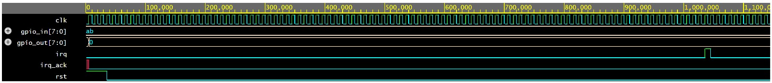

Device Under Test

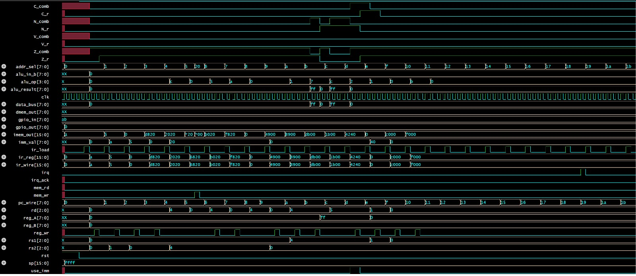

Arithmetic Logic Unit

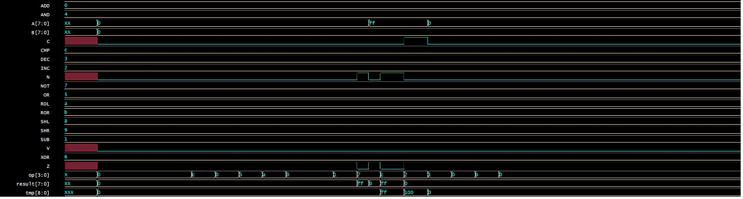

DataMemory

Instruction Memory

Control Unit

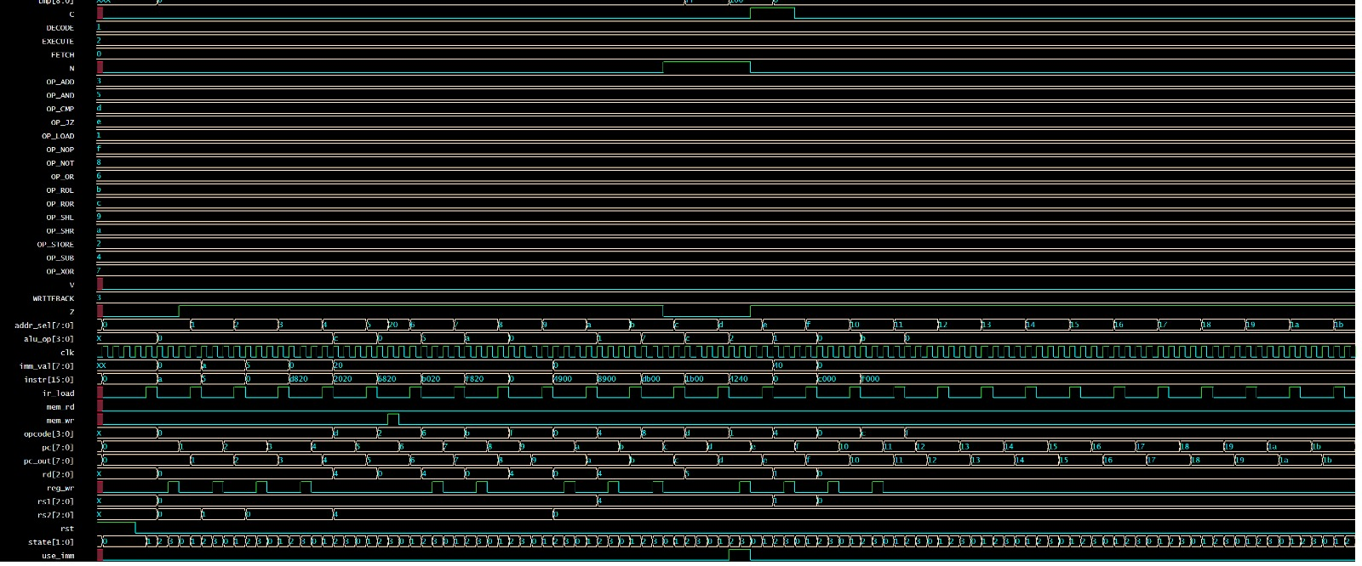

Fill/Initialization

Input/Output

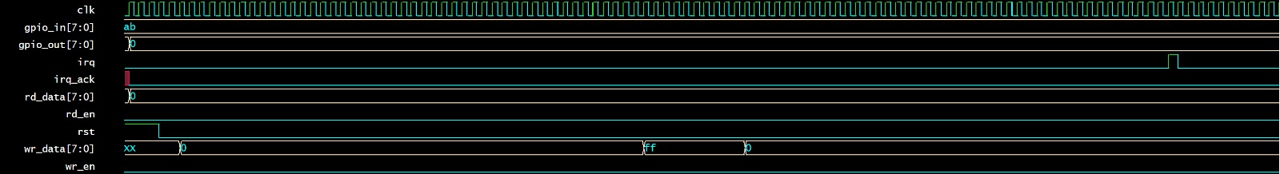

Register File

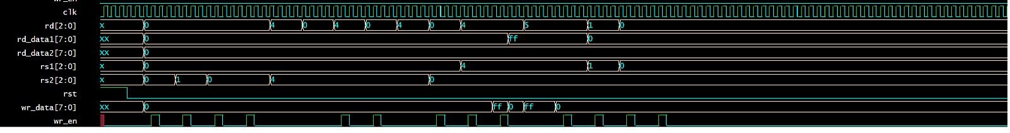

8. APPLICATIONS AND USE CASES

8.1 Microcontroller Cores

The processor can serve as the core of a custom microcontroller when augmented with peripheral IP blocks such as UART, SPI, I2C, PWM generators, and ADC interfaces. This mirrors the architecture of commercial parts like ATmega328P (Arduino) or PIC16F series, which are built on very similar 8-bit RISC cores.

8.2 IoT Edge Devices

Low-power 8-bit RISC cores are ideal for IoT sensor nodes that perform simple data acquisition, threshold comparison, and wireless transmission tasks. Their small silicon footprint translates directly into lower power consumption and cost, critical for battery-operated devices.

8.3 Educational Platforms

Custom processor designs on FPGA are widely used in computer architecture courses to give students hands-on experience with processor internals. The transparent architecture of this design makes it ideal for teaching instruction pipelines, hazard detection, cache design, and interrupt handling.

8.4 Custom Accelerators

Domain-specific processors derived from this architecture can be specialized for tasks such as digital signal processing (DSP), motor control, cryptographic operations, or sensor fusion by modifying the ALU instruction set and adding application-specific hardware extensions.

9. Conclusion and Future Scope
9.1 Conclusion
This project successfully designed and implemented a fully functional 8-bit RISC processor architecture incorporating all essential components of a modern embedded processor: a synchronous clock and reset system, a Harvard-architecture memory interface with separate 64 KB instruction ROM and data RAM, a 16-bit Program Counter, a 16-bit Address Bus, an 8-bit Data Bus, an Instruction Register, a Register File with eight general-purpose 8-bit registers, a comprehensive ALU supporting 13 operations, a Status Register with four condition flags, a 16-bit Stack Pointer, and an External I/O Interface with interrupt support. The design was validated through extensive functional simulation confirming correct execution of all instruction types.
The project demonstrates that RISC architecture principles — simplicity, regularity, load-store operation, and large register files — naturally lead to clean, efficient hardware implementations. The Harvard architecture's separation of instruction and data memory provides a meaningful performance advantage over Von Neumann designs in embedded contexts. The resulting design is a solid foundation for FPGA deployment and further architectural exploration.

9.2 Future Scope
- Pipeline Implementation: Extend the design to a 5-stage pipeline (Fetch, Decode, Execute, Memory, Writeback) to increase instruction throughput. This would require hazard detection and forwarding logic.
- 16-bit and 32-bit Extensions: Scale the data bus and ALU to 16 or 32 bits to handle wider data types natively.
- Cache Memory: Add a small instruction cache and data cache to reduce memory access latency.
- Floating-Point Unit (FPU): Integrate a hardware FPU for scientific and DSP applications requiring real-number arithmetic.
- Branch Predictor: Implement a simple branch predictor (e.g., 2-bit saturating counter) to reduce pipeline flush penalties in pipelined versions.
- RISC-V Compatible ISA: Migrate the instruction set to a RISC-V compatible base ISA to leverage the extensive RISC-V toolchain (GCC, LLVM, Spike).
- Operating System Support: Add privilege levels, memory protection units, and system call mechanisms to support lightweight RTOS operation.

REFERENCES

[1] D. A. Patterson and J. L. Hennessy, Computer Organization and Design: The Hardware/Software Interface, 5th ed. Burlington, MA, USA: Morgan Kaufmann, 2014.

[2] J. L. Hennessy and D. A. Patterson, Computer Architecture: A Quantitative Approach, 6th ed. Cambridge, MA, USA: Morgan Kaufmann, 2019.

[3] M. M. Mano and M. D. Ciletti, Digital Design, 5th ed. Upper Saddle River, NJ, USA: Pearson, 2013.

[4] D. M. Harris and S. L. Harris, Digital Design and Computer Architecture, 2nd ed. Waltham, MA, USA: Morgan Kaufmann, 2012.

[5] C. H. Roth Jr. and L. L. Kinney, Fundamentals of Logic Design, 7th ed. Boston, MA, USA: Cengage Learning, 2014.

[6] S. Palnitkar, Verilog HDL: A Guide to Digital Design and Synthesis, 2nd ed. Upper Saddle River, NJ, USA: Prentice Hall, 2003.

[7] IEEE Standard for Verilog Hardware Description Language, IEEE Std 1364-2005, 2006.

[8] IEEE Standard for SystemVerilog—Unified Hardware Design, Specification, and Verification Language, IEEE Std 1800-2017, 2018.

[9] J. Bhasker, A Verilog HDL Primer, 3rd ed. Star Galaxy Publishing, 2003.

[10] Xilinx Inc., Vivado Design Suite User Guide, San Jose, CA, USA, 2020.

